**MEETING MINUTES: SUMO DIGITAL GROUP PROJECT**

**Date of meeting:** 05/03/2019

**Time of meetin**g: 4:00 PM

**Attendees**: Dragos Liche, Dawid Hojka, Alex Butler and Anthony Skipwith

**Mid-sprint review:**

Overall, the main aim of this week was to get the game to the state that it is ready to be presented during the pitch the following week (6/03). All of the tasks required for us to proceed were completed on time and so on today’s meeting we mainly focused on getting everything together and creating the actual presentation.

We did encounter few issues with downloading our game project from the GitHub repository, as it had stuff missing, and didn’t want to work correctly on a different machine. However we were able to find a solution to the problem. Unfortunately, the issues have caused a little disorganisation within our GitHub repository, as the game project contents were uploaded into the main folder. We will fix that issue in the upcoming sprint.

**Individual work completed:-**

* **Dragos:** Completed the bar level, along with some additional props to be used within it.
* **Dawid:** Imported all animations into Unity, as well as added the hitboxes into the game.
* **Anthony:** Implemented all features into one project, as well as imported in all the assets.
* **Alex:** Fixed the table textures. Also researched and designed the reticle UI. Also designed UI elements for health and ammo.

**Meeting ended:** 6:40 PM

**Minute taker:** Dawid Hojka

**Discord Discussion Documentation:**

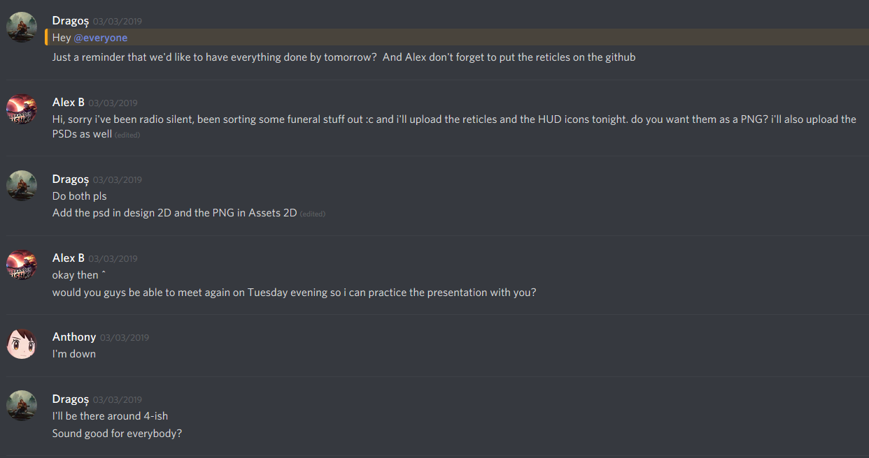 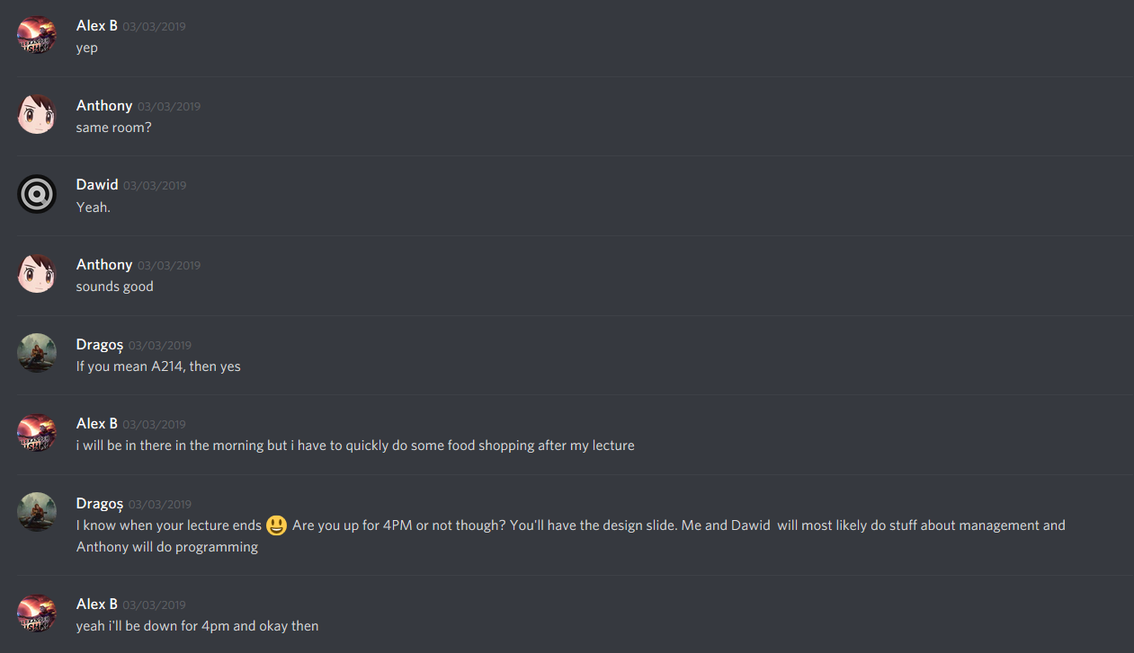 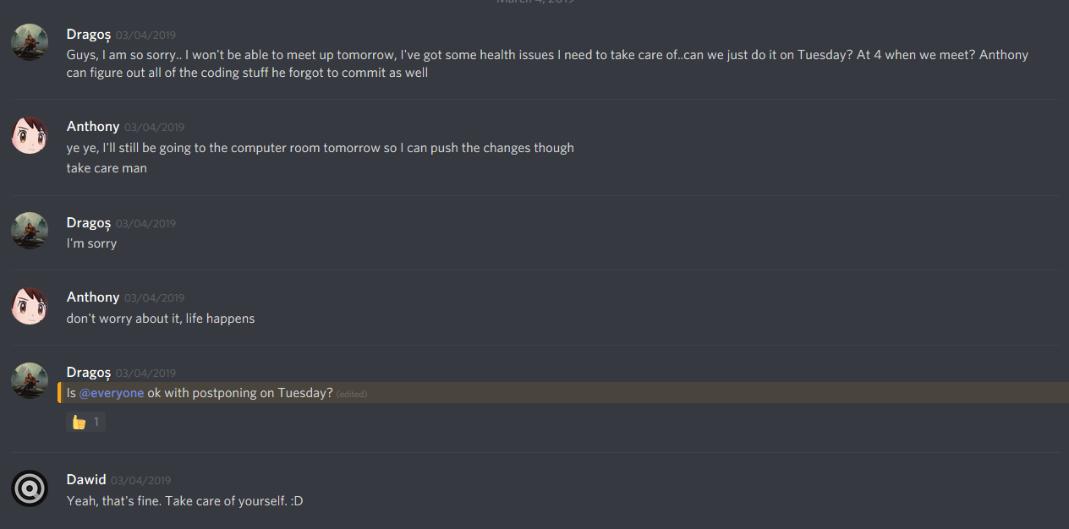

Screenshots 1 – 3 – Arranging a meeting on Monday, to finish up and get everything ready for the presentation. However due to Dragos having health issues, the meeting was postponed, so that we all can be present when creating the presentation.

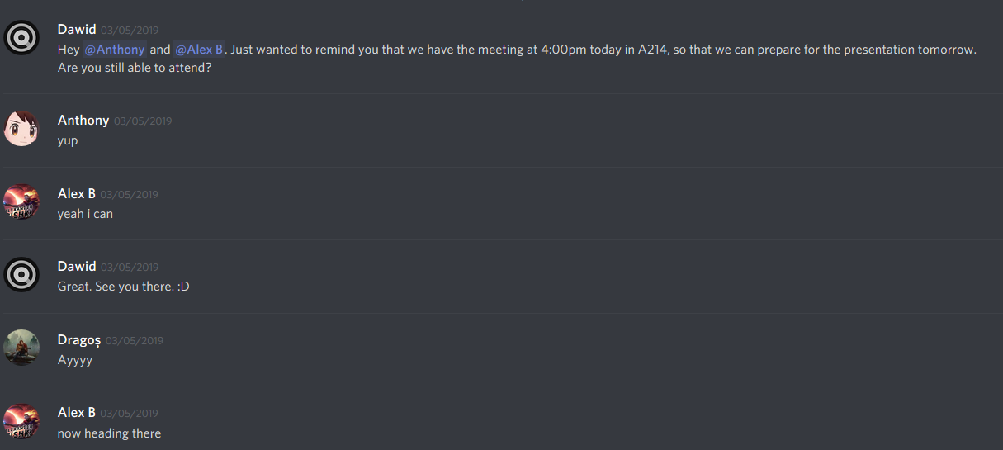

Screenshot 4 – Reminding Alex and Anthony that we have a meeting at 4:00pm.

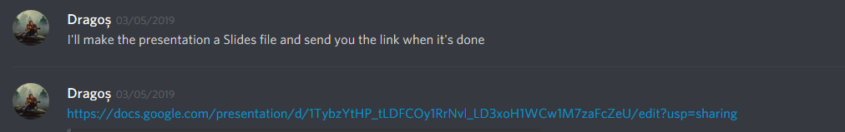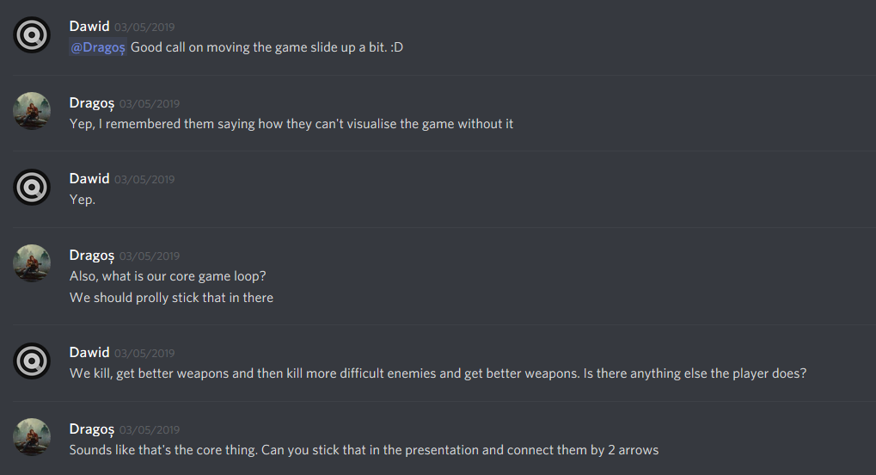 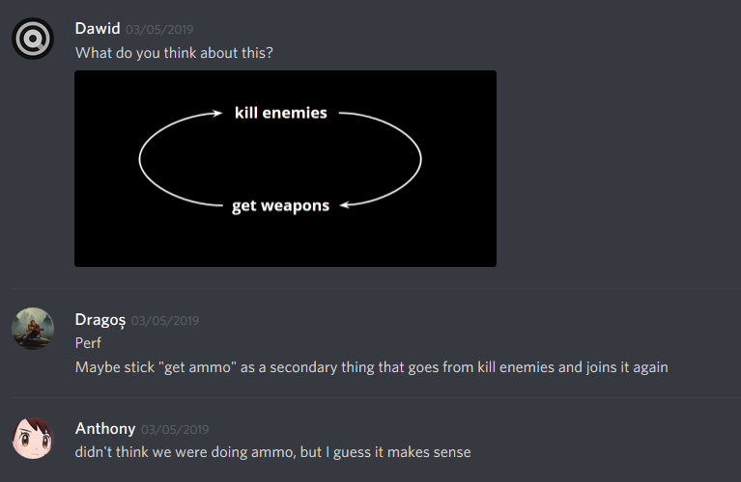 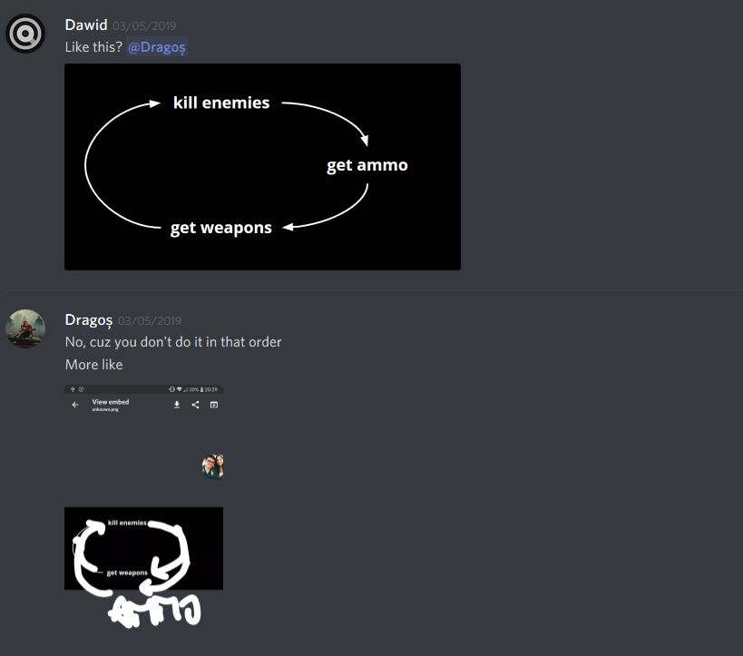 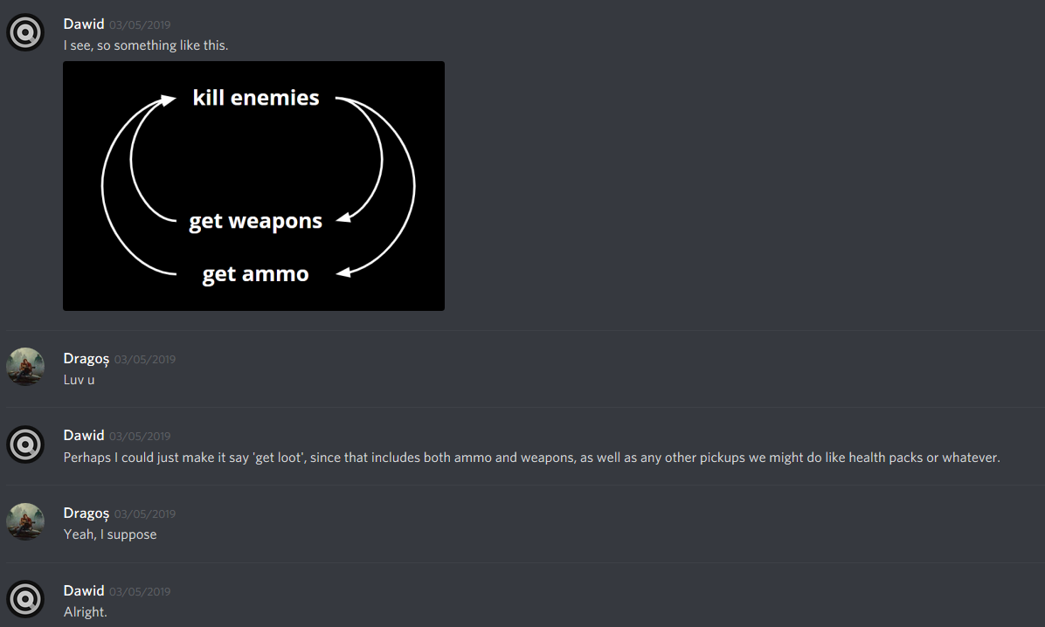 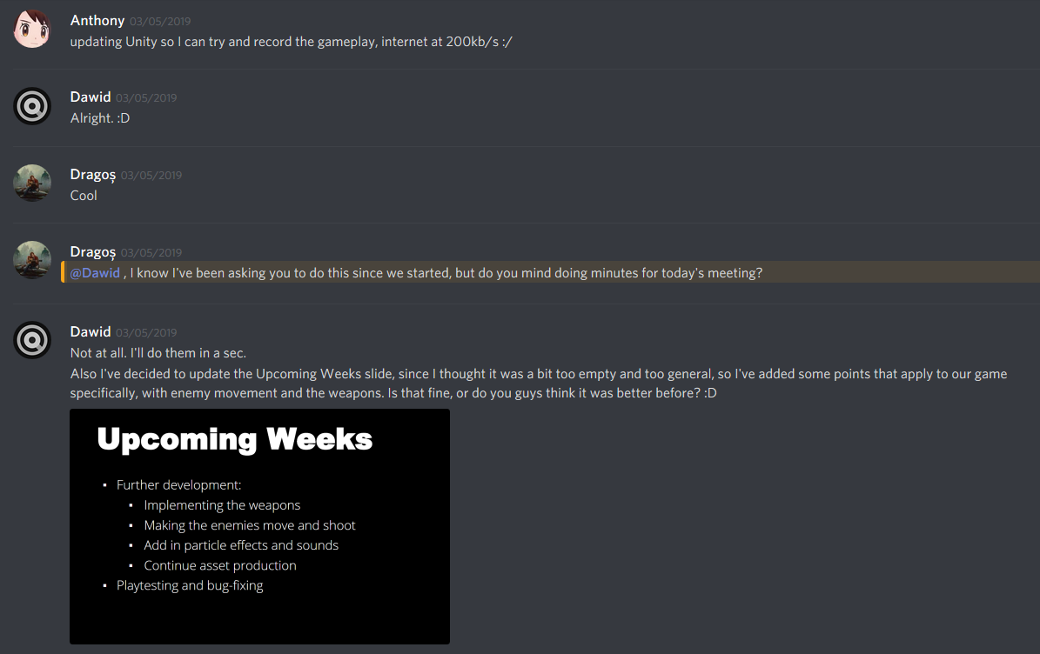 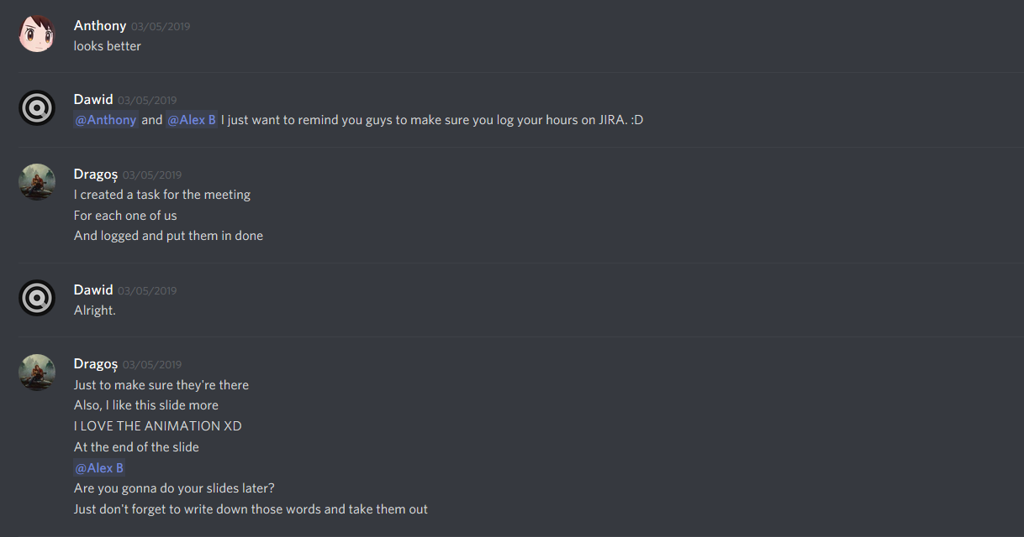 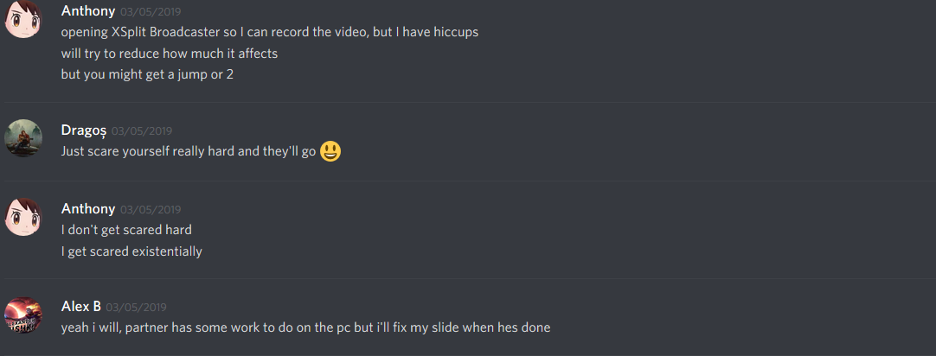 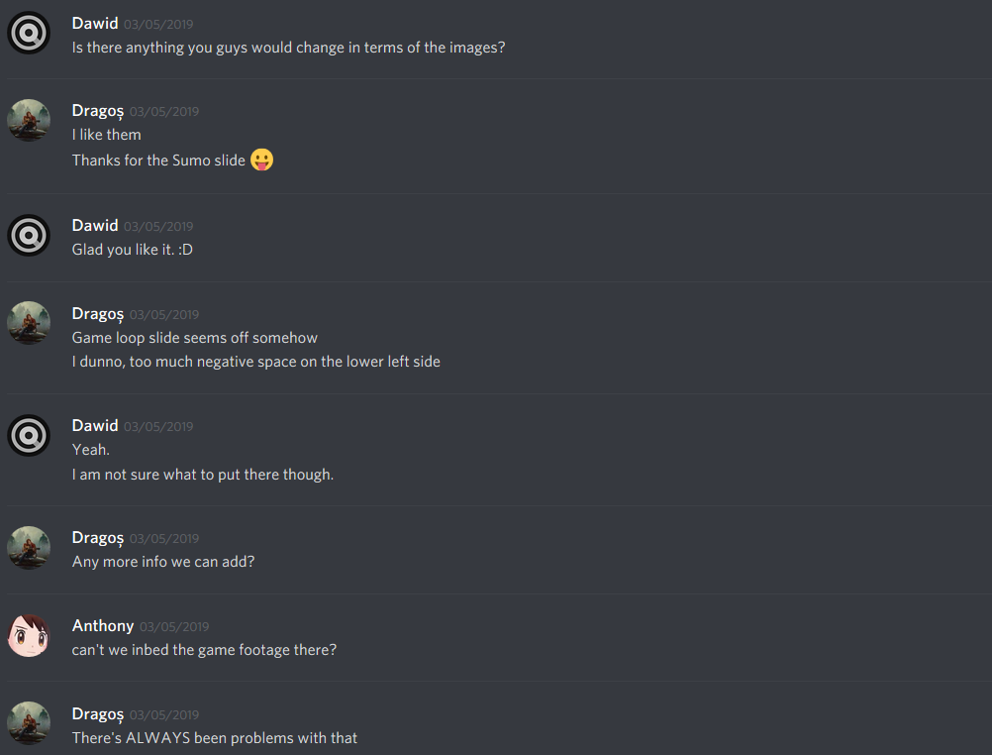 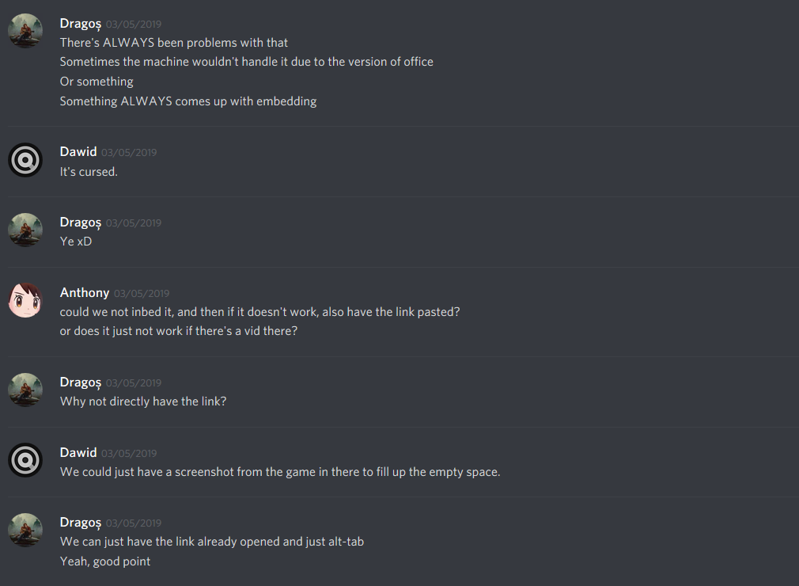 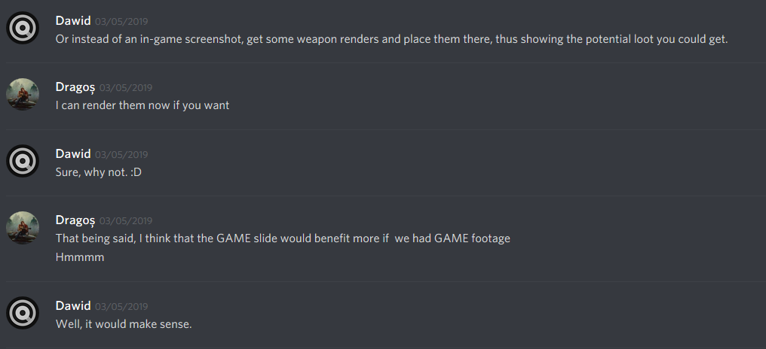

Screenshots 5 – 15 - The above discussion revolves around us working on the presentation slides.